**Numerical Computation - Assignment 6**

**薛劭杰 1930026143**

**Q1.**

The number of flops to create L and U is equal to Gaussian Elimination is:

$2\sum_{j=1}^{n}{j^{2}}-\sum_{j=1}^{n}{j}-\sum_{j=1}^{n}{1}=2\left(\frac{1}{6}n\left(n+1\right)\left(2n+1\right)\right)-\frac{1}{2}n\left(n+1\right)-n$

$=\left(\frac{2}{3}n-\frac{1}{6}\right)n\left(n+1\right)-n=\frac{2}{3}n^{3}+\frac{2}{3}n^{2}-\frac{1}{6}n^{2}-\frac{1}{6}n-n$

$=\frac{2}{3}n^{3}+\frac{1}{2}n^{2}-\frac{7}{6}n ⇒\frac{2}{3}n^{3}$

The number of flops for forward substitution is:

$0+2+4+…+2*\left(n-1\right)=2*\left(1+2+…+n-1\right)$

$=2*\frac{1}{2}\left(n-1\right)\left(n-2\right)=n^{2}-3n+2⇒n^{2}$

The number of flops for backward substitution is:

$1+3+5+…+2n-1=\frac{\left(1+2n-1\right)n}{2}=n^{2}⇒n^{2}$

$Solve the first problem:\frac{2}{3}n^{3}$

$100 problems by LU method: 100*\left(n^{2}+n^{2}\right)$

Build equation:

$\frac{2}{3}n^{3}=100*\left(n^{2}+n^{2}\right)$

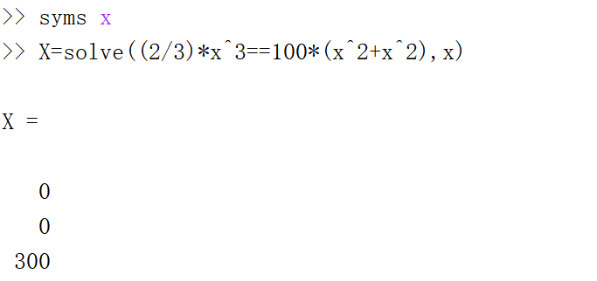

$n≠0，so n=300$

**Q2.**

${|\left|Ax\right||}_{∞}=\max_{1≤i≤n}{[\sum_{j=1}^{n}{\left|a_{ij}*x_{j}\right|}]}≤ \max_{1≤i≤n}{[\sum_{j=1}^{n}{\left|a_{ij}\right|*|x_{j}|}]}$

Expand this expression:

$\max_{1≤i≤n}{[\sum_{j=1}^{n}{\left|a_{ij}\right|*|x_{j}|}]}=\left[\begin{matrix}\begin{matrix}{|a}_{11}|\left|x_{1}\right|+ & ⋯ \\ {|a}_{21}|\left|x_{1}\right|+ & ⋯\end{matrix} & \begin{matrix}⋯ & +\left|a_{1n}\right||x_{1}| \\ ⋯ & +{|a}_{2n}|\left|x_{1}\right|\end{matrix} \\ \begin{matrix}…… & \\ {|a}_{n1}|\left|x_{1}\right|+ & ⋯\end{matrix} & \begin{matrix} & …… \\ ⋯ & +\left|a_{nn}\right||x_{n}|\end{matrix}\end{matrix}\right]$

Then use ${\left|\left|x\right|\right|}_{∞}$ to replace the all $\left|x_{j}\right|$, and since ${\left|\left|x\right|\right|}_{∞}=\max_{1≤j≤n}|j|$

$\max_{1≤i≤n}{[\sum_{j=1}^{n}{\left|a_{ij}\right|*|x_{j}|}]}≤\left[\begin{matrix}\begin{matrix}{(|a}_{11}|+\left|a_{12}\right|+ & ⋯ \\ {(|a}_{21}|+|a_{22}|+ & ⋯\end{matrix} & \begin{matrix}⋯ & +\left|a_{1n}\right|)*{\left|\left|x\right|\right|}_{∞} \\ ⋯ & +{|a}_{2n}|)*{\left|\left|x\right|\right|}_{∞}\end{matrix} \\ \begin{matrix}…… & \\ {(|a}_{n1}|+|a_{n2}|+ & ⋯\end{matrix} & \begin{matrix} & …… \\ ⋯ & +\left|a_{nn}\right|)*{\left|\left|x\right|\right|}_{∞}\end{matrix}\end{matrix}\right]$

$So \max_{1≤i≤n}{[\sum_{j=1}^{n}{\left|a_{ij}\right|*|x_{j}|}]}≤\max_{1≤i≤n}\left[\sum_{j=1}^{n}{\left|a_{ij}\right|*{\left|\left|x\right|\right|}_{∞}}\right]$.

Take the ${\left|\left|x\right|\right|}_{∞}=1$:

$\max_{1≤i≤n}\left[\sum_{j=1}^{n}{\left|a_{ij}\right|*{\left|\left|x\right|\right|}_{∞}}\right]=\max_{1≤i≤n}\left[\sum_{j=1}^{n}{\left|a_{ij}\right|}\right]={|\left|A\right||}_{∞}$.

Q3.

A is a diagonal matrix = $\left[\begin{matrix}\begin{matrix}1 & 0 & 0 \\ 0 & \frac{1}{2} & 0 \\ 0 & 0 & \frac{1}{3}\end{matrix} & \begin{matrix}… & 0 \\ … & 0 \\ … & 0\end{matrix} \\ \begin{matrix}… & … & … \\ 0 & 0 & 0\end{matrix} & \begin{matrix}… & … \\ … & \frac{1}{n}\end{matrix}\end{matrix}\right]$

$L^{1}$ norm: ${\left|\left|A\right|\right|}_{1}=\max_{1≤j≤n}\left[\sum_{i=1}^{n}{\left|a_{ij}\right|}\right]=1$.

$L^{2}$ norm: A is a diagonal matrix, then $A^{T}A$ is also a diagonal matrix. The eigenvalues of $A^{T}A$

are equal to the element values in this diagonal, so the maximum eigenvalue of $A^{T}A$ is 1.

${\left|\left|A\right|\right|}_{2}=\sqrt{λ_{max}(A^{T}A)}=1$.

$L^{∞}$ norm: ${\left|\left|A\right|\right|}_{∞}=\max_{1≤i≤n}\left[\sum_{j=1}^{n}{\left|a_{ij}\right|}\right]=1$.

Q4.

1. Initially, transform the linear system to matrix $A*x=b$

$A=\left[\begin{matrix}1 & -2 \\ 3 & -4\end{matrix} \right], x=\left[\begin{matrix}x_{1} \\ x_{2}\end{matrix}\right], b=[\begin{matrix}3 \\ 7\end{matrix}]$.

Then use the Gaussian elimination to get the solution:

$\left[\begin{matrix}1 & -2 & 3 \\ 3 & -4 & 7\end{matrix} \right]→\left[\begin{matrix}1 & -2 & 3 \\ 0 & 2 & -2\end{matrix} \right]$ by $r_{2}-3r_{1}$.

By back substitution, $x_{2}=-1, x_{1}=1$. $So$ actual solution $x=\left[\begin{matrix}1 \\ -1\end{matrix}\right]$.

The approximation solution $x_{α}=\left[\begin{matrix}-1 \\ -1\end{matrix}\right]$, so $error Δx=x_{α}-x=\left[\begin{matrix}-2 \\ 0\end{matrix}\right]$.

${\left|\left|x\right|\right|}_{∞}=\max_{1≤i≤n}\left[\sum_{j=1}^{n}{\left|x_{ij}\right|}\right]=1$, ${\left|\left|Δx\right|\right|}_{∞}=\max_{1≤i≤n}\left[\sum_{j=1}^{n}{\left|{Δx}_{ij}\right|}\right]=2$.

And then calculate $b_{α}=A*x_{α}=\left[\begin{matrix}1 & -2 \\ 3 & -4\end{matrix}\right]*\left[\begin{matrix}-1 \\ -1\end{matrix}\right]=\left[\begin{matrix}1 \\ 1\end{matrix}\right]$. $residual Δb=b_{α}-b=\left[\begin{matrix}-2 \\ -6\end{matrix}\right]$.

${\left|\left|b\right|\right|}_{∞}=\max_{1≤i≤n}\left[\sum_{j=1}^{n}{\left|b_{ij}\right|}\right]=7$, ${\left|\left|Δb\right|\right|}_{∞}=\max_{1≤i≤n}\left[\sum_{j=1}^{n}{\left|{Δb}_{ij}\right|}\right]=6$.

The relative forward error: $\frac{{\left|\left|Δx\right|\right|}_{∞}}{{\left|\left|x\right|\right|}_{∞}}=\frac{2}{1}=2$

The relative backward error: $\frac{{\left|\left|Δb\right|\right|}_{∞}}{{\left|\left|b\right|\right|}_{∞}}=\frac{6}{7}≈0.8571$

The error magnification factor: $\frac{relative forward error}{relative backward error}=\frac{\frac{{\left|\left|Δx\right|\right|}_{∞}}{{\left|\left|x\right|\right|}_{∞}}}{\frac{{\left|\left|Δb\right|\right|}_{∞}}{{\left|\left|b\right|\right|}_{∞}}}=\frac{2}{\frac{6}{7}}≈2.3333$

1. Let $M=max\frac{{\left|\left|Ax\right|\right|}_{∞}}{{\left|\left|x\right|\right|}_{∞}}={\left|\left|A\right|\right|}_{∞}=7$, $m=min\frac{{\left|\left|Ax\right|\right|}_{∞}}{{\left|\left|x\right|\right|}_{∞}}$.

If $Ax=y$, then $x=A^{-1}y$ and $m=min\frac{{\left|\left|Ax\right|\right|}_{∞}}{{\left|\left|x\right|\right|}_{∞}}=min\frac{{\left|\left|y\right|\right|}_{∞}}{{\left|\left|A^{-1}y\right|\right|}_{∞}}=\frac{1}{max\frac{{\left|\left|A^{-1}y\right|\right|}_{∞}}{{\left|\left|y\right|\right|}_{∞}}}=\frac{1}{{\left|\left|A^{-1}\right|\right|}_{∞}}$

$A^{-1}=\left[\begin{matrix}-2 & 1 \\ -1.5 & 0.5\end{matrix}\right]$, ${\left|\left|A^{-1}\right|\right|}_{∞}=3$

$A=\left[\begin{matrix}1 & -2 \\ 3 & -4\end{matrix}\right]$, condition number of $A=k\left(A\right)=\frac{M}{m}={\left|\left|A\right|\right|}_{∞}*{\left|\left|A^{-1}\right|\right|}_{∞}=21$

Q5.

1. $A=\left[\begin{matrix}1 & 2 \\ 2 & 4.001\end{matrix}\right]$, $A^{-1}=[\begin{matrix}4001 & -2000 \\ 2000 & 1000\end{matrix}]$

${\left|\left|A\right|\right|}_{∞}=\max_{1≤i≤n}\left[\sum_{j=1}^{n}{\left|a_{ij}\right|}\right]=6.001$, ${\left|\left|A^{-1}\right|\right|}_{∞}=\max_{1≤i≤n}\left[\sum_{j=1}^{n}{\left|A_{ij}^{-1}\right|}\right]=$ 6001

Condition number of $A=k\left(A\right)={\left|\left|A\right|\right|}_{∞}*{\left|\left|A^{-1}\right|\right|}_{∞}=6001*6.001=36012.001$.

1. $x=\left[\begin{matrix}1 \\ 1\end{matrix}\right], x_{α}=[\begin{matrix}-6000 \\ 3001\end{matrix}]$. $So$ e $rror Δx=x_{α}-x=\left[\begin{matrix}-6001 \\ 3000\end{matrix}\right]$

${\left|\left|x\right|\right|}_{∞}=\max_{1≤i≤n}\left[\sum_{j=1}^{n}{\left|x_{ij}\right|}\right]=1, {\left|\left|Δx\right|\right|}_{∞}=\max_{1≤i≤n}\left[\sum_{j=1}^{n}{\left|{Δx}_{ij}\right|}\right]=6001$

The relative forward error: $\frac{{\left|\left|Δx\right|\right|}_{∞}}{{\left|\left|x\right|\right|}_{∞}}=\frac{6001}{1}=6001$

$b=\left[\begin{matrix}3 \\ 6.001\end{matrix}\right], b_{α}=A*x_{α}=\left[\begin{matrix}1 & 2 \\ 2 & 4.001\end{matrix}\right]*\left[\begin{matrix}-6000 \\ 3001\end{matrix}\right]=\left[\begin{matrix}2 \\ 7.001\end{matrix}\right]$

$So$ residual $Δb=b_{α}-b=\left[\begin{matrix}2 \\ 7.001\end{matrix}\right]-\left[\begin{matrix}3 \\ 6.001\end{matrix}\right]=[\begin{matrix}-1 \\ 1\end{matrix}]$.

${\left|\left|b\right|\right|}_{∞}=\max_{1≤i≤n}\left[\sum_{j=1}^{n}{\left|b_{ij}\right|}\right]=6.001, {\left|\left|Δb\right|\right|}_{∞}=\max_{1≤i≤n}\left[\sum_{j=1}^{n}{\left|{Δb}_{ij}\right|}\right]=1$

The relative backward error: $\frac{{\left|\left|Δb\right|\right|}_{∞}}{{\left|\left|b\right|\right|}_{∞}}=\frac{1}{6.001}$

The error magnification factor: $\frac{relative forward error}{relative backward error}=\frac{\frac{{\left|\left|Δx\right|\right|}_{∞}}{{\left|\left|x\right|\right|}_{∞}}}{\frac{{\left|\left|Δb\right|\right|}_{∞}}{{\left|\left|b\right|\right|}_{∞}}}=\frac{6001}{\frac{1}{6.001}}=36012.001$

$A=\left[\begin{matrix}1 & 2 \\ 2 & 4.001\end{matrix}\right], x=\left[\begin{matrix}1 \\ 1\end{matrix}\right]$

$x_{α}=\left[\begin{matrix}1-6001δ \\ 1+3000δ\end{matrix}\right]$, $So$ e $rror Δx=x_{α}-x=\left[\begin{matrix}1-6001δ \\ 1+3000δ\end{matrix}\right]-\left[\begin{matrix}1 \\ 1\end{matrix}\right]=\left[\begin{matrix}-6001δ \\ 3000δ\end{matrix}\right]$

${\left|\left|x\right|\right|}_{∞}=\max_{1≤i≤n}\left[\sum_{j=1}^{n}{\left|x_{ij}\right|}\right]=1, {\left|\left|Δx\right|\right|}_{∞}=\max_{1≤i≤n}\left[\sum_{j=1}^{n}{\left|{Δx}_{ij}\right|}\right]=6001δ$ since $δ>0$.

$b=\left[\begin{matrix}3 \\ 6.001\end{matrix}\right], b_{α}=A*x_{α}=\left[\begin{matrix}1 & 2 \\ 2 & 4.001\end{matrix}\right]*\left[\begin{matrix}-6001δ \\ 3000δ\end{matrix}\right]=\left[\begin{matrix}3-δ \\ δ+6.001\end{matrix}\right]$

$So$ residual $Δb=b_{α}-b=\left[\begin{matrix}3-δ \\ δ+6.001\end{matrix}\right]-\left[\begin{matrix}3 \\ 6.001\end{matrix}\right]=\left[\begin{matrix}-δ \\ δ\end{matrix}\right]$.

${\left|\left|b\right|\right|}_{∞}=6.001$, ${\left|\left|Δb\right|\right|}_{∞}=\max_{1≤i≤n}\left[\sum_{j=1}^{n}{\left|{Δb}_{ij}\right|}\right]=δ$

The relative forward error: $\frac{{\left|\left|Δx\right|\right|}_{∞}}{{\left|\left|x\right|\right|}_{∞}}=\frac{2}{1}=2$

The relative backward error: $\frac{{\left|\left|Δb\right|\right|}_{∞}}{{\left|\left|b\right|\right|}_{∞}}=\frac{6}{7}≈0.8571$

The error magnification factor: $\frac{relative forward error}{relative backward error}=\frac{\frac{{\left|\left|Δx\right|\right|}_{∞}}{{\left|\left|x\right|\right|}_{∞}}}{\frac{{\left|\left|Δb\right|\right|}_{∞}}{{\left|\left|b\right|\right|}_{∞}}}=\frac{6001δ}{\frac{δ}{6.001}}=36012.001$

According to the (a), the condition number of $A$ is $36012.001$ which is equal to the error magnification factor of approximation solution $x_{α}=\left[\begin{matrix}1-6001δ \\ 1+3000δ\end{matrix}\right]$ for any $δ>0$.

Q6.

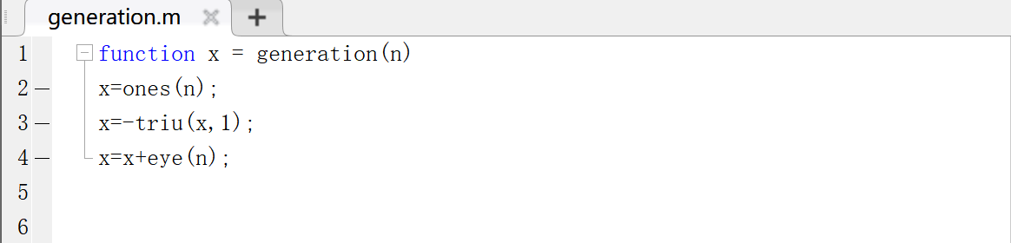

Test the function by $n=10$:

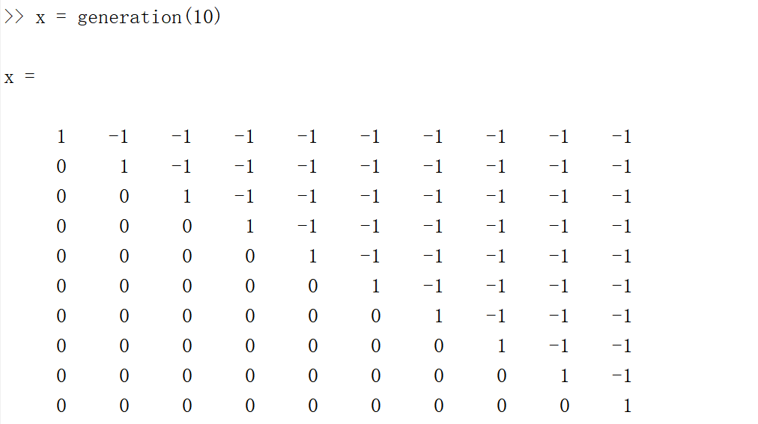

$A=\left[\begin{matrix}1 & -1 & \begin{matrix}… & -1\end{matrix} \\ 0 & 1 & \begin{matrix}… & -1\end{matrix} \\ \begin{matrix}… \\ 0\end{matrix} & \begin{matrix}… \\ …\end{matrix} & \begin{matrix}\begin{matrix}⋱ & …\end{matrix} \\ \begin{matrix}0 & 1\end{matrix}\end{matrix}\end{matrix}\right]$, $a_{ij}=\left\{\begin{aligned}-1 i<j \\ 1 i=j \\ 0 i>j\end{aligned}\right.$

When $n=1:$ $A=\left[1\right], A^{-1}=[1]$

When $n=2:$ $A=\left[\begin{matrix}1 & 1 \\ 0 & 1\end{matrix}\right], A^{-1}=[1]$

When $n=3:$ $A=\left[\begin{matrix}1 & -1 & -1 \\ 0 & 1 & -1 \\ 0 & 0 & 1\end{matrix}\right], A^{-1}=\left[\begin{matrix}1 & 1 & 2 \\ 0 & 1 & 1 \\ 0 & 0 & 1\end{matrix}\right]$

When $n=4:$ $A=\left[\begin{matrix}\begin{matrix}1 & -1 \\ 0 & 1\end{matrix} & \begin{matrix}-1 & -1 \\ -1 & -1\end{matrix} \\ \begin{matrix}0 & 0 \\ 0 & 0\end{matrix} & \begin{matrix}1 & -1 \\ 0 & 1\end{matrix}\end{matrix}\right], A^{-1}=\left[\begin{matrix}\begin{matrix}1 & 1 \\ 0 & 1\end{matrix} & \begin{matrix}2 & 4 \\ 1 & 2\end{matrix} \\ \begin{matrix}0 & 0 \\ 0 & 0\end{matrix} & \begin{matrix}1 & 1 \\ 0 & 1\end{matrix}\end{matrix}\right]$

…

By induction, we can find that the inverse matrix of A $=A^{-1}=\left[\begin{matrix}1 & 2^{0} & \begin{matrix}2^{1} & \begin{matrix}⋯ & 2^{n-2}\end{matrix}\end{matrix} \\ 0 & 1 & \begin{matrix}2^{0} & \begin{matrix}⋯ & 2^{n-1}\end{matrix}\end{matrix} \\ \begin{matrix}⋮ \\ \begin{matrix}0 \\ 0\end{matrix}\end{matrix} & \begin{matrix}⋱ \\ \begin{matrix}0 \\ 0\end{matrix}\end{matrix} & \begin{matrix}\begin{matrix}⋱ & \begin{matrix}⋱ & ⋮\end{matrix}\end{matrix} \\ \begin{matrix}\begin{matrix}⋱ \\ 0\end{matrix} & \begin{matrix}\begin{matrix}1 \\ 0\end{matrix} & \begin{matrix}2^{0} \\ 1\end{matrix}\end{matrix}\end{matrix}\end{matrix}\end{matrix}\right]$

${\left|\left|A\right|\right|}_{1}=\max_{1≤j≤n}\left[\sum_{i=1}^{n}{\left|a_{ij}\right|}\right]=n*1=n$

Since $2^{n-1}+2^{n-2}+…+2^{1}+2^{0}=2^{n}-1$, ${\left|\left|A^{-1}\right|\right|}_{1}=\max_{1≤j≤n}\left[\sum_{i=1}^{n}{\left|A_{ij}^{-1}\right|}\right]=\left(2^{n-2}+2^{n-1}+…+2^{0}\right)+1=2^{n-2+1}=2^{n-1}$.

Condition number of $A=k\left(A\right)={\left|\left|A\right|\right|}_{1}*{\left|\left|A^{-1}\right|\right|}_{1}=n*2^{n-1}$.